HYDRAPOWER & BOEING CORP

In June 1980 Hydrapower shipped a 28’ X 750 ton Press Brake to the new plant in Tulsa, Oklahoma.
Several years passed then we learned that the machine had been shipped to the Seattle plant and installed on a new foundation. After a few more years we heard from the Boeing, Maintenance Supervisor, who told us it was now being moved to the new Wichita Kansas plant. During 1995 we were told the machine had been moved again into the newest building at the Wichita plant.

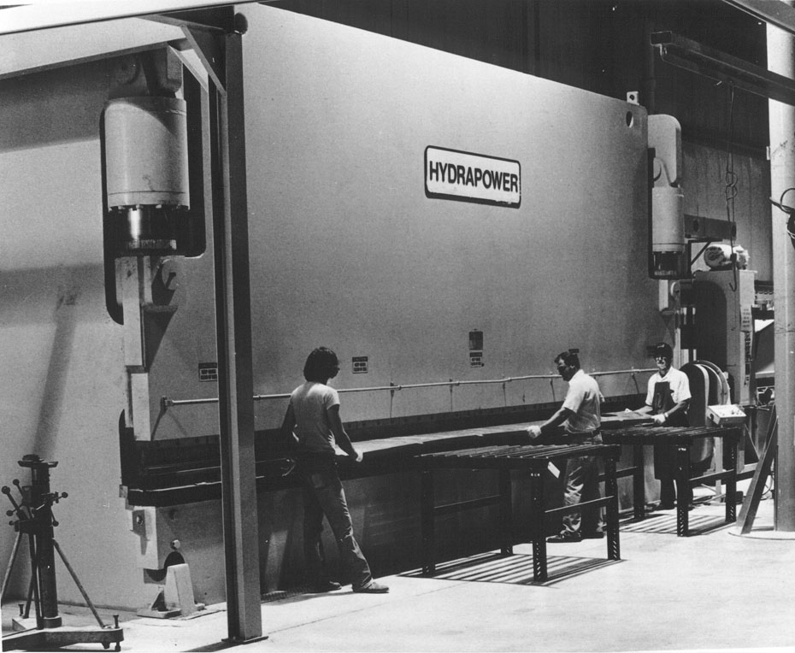

The machine is now 28 years old and still in great condition. Hydrapower believes that the moving and foundation/pits etc would have probably cost double the original purchase price of the machine. This would indicate that Boeing appreciated the real value of this old Hydrapower Press Brake.

